Name : Sahil Saini Salaria
Reg N o : 180905048
Roll No. 11C
Batch C1

Q1

<!DOCTYPE html>
<html lang="en">
<head>
<link rel="stylesheet" href="q1.css">
<title>Document</title>
</head>
<body>

<script src="https://cdn.freecodecamp.org/testable-projects-fcc/v1/bundle.js"></script>

<h1 id="title">Bio Data Form</h1>
<div id="form-outer">

<form id="survey-form" method="GET" action="">
<div class="rowTab">
<div class="labels">
<label id="name-label" for="name">Name: </label>
</div>
<div class="rightTab">
<input autofocus type="text" name="name" id="name" class="input-field" placeholder="Enter your name" required>
</div>
</div>

<div class="rowTab">
<div class="labels">
<label id="fname-label" for="fname">Father's Name: </label>
</div>
<div class="rightTab">
<input autofocus type="text" name="fname" id="fname" class="input-field" placeholder="Enter your father's name" required>
</div>
</div>

<div class="rowTab">
<div class="labels">
<label id="mname-label" for="mname">Mother's Name: </label>
</div>
<div class="rightTab">
<input autofocus type="text" name="mname" id="mname" class="input-field" placeholder="Enter your mother's name" required>
</div>
</div>

<div class="rowTab">
<div class="labels">
<label id="email-label" for="email">Email: </label>
</div>
<div class="rightTab">
<input type="email" name="email" id="email" class="input-field" required placeholder="Enter your Email">
</div>
</div>
<div class="rowTab">
<div class="labels">
<label id="number-label" for="age">Age: </label>
</div>
<div class="rightTab">
<input type="number" name="age" id="number" min="1" max="125" class="input-field" placeholder="Age" required>
</div>
</div>

<div class="rowTab">
<div class="labels">
<label id="dob-label" for="dob">D.O.B: </label>
</div>
<div class="rightTab">
<input type="date" name="dob" id="iddob" class="input-field" required>
</div>
</div>

<div class="rowTab">
<div class="labels">
<label for="department">Department: </label>
</div>
<div class="rightTab">
<select id="dropdown" name="department" class="dropdown">
<option disabled value>Select an option</option>
<option value="it">IT</option>
<option value="cse">CSE</option>
<option value="ece">ECE</option>
<option value="mech">MECH</option>
<option value="civil">CIVIL</option>
<option value="other">Other</option>
</select>
</div>
</div>

<div class="rowTab">
<div class="labels">
<label for="gender">Gender: </label>
</div>
<div class="rightTab">
<ul style="list-style: none;">
<li class="radio"><label><input name="radio-buttons" value="male" type="radio" class="userRatings" >Male</label></li>
<li class="radio"><label><input name="radio-buttons" value="female" type="radio" class="userRatings" >Female</label></li>
<li class="radio"><label><input name="radio-buttons" value="others" type="radio" class="userRatings" >Others</label></li>
</ul>
</div>
</div>
<div class="rowTab">
<div class="labels">
<label for="address">Address: </label>
</div>
<div class="rightTab">
<textarea id="comments" class="input-field" style="height:50px;resize:vertical;" name="address" placeholder="Enter your address here..."></textarea>
</div>
</div>
<div class="rowTab">

<div class="rowTab">
<div class="labels">
<label for="language">Language Known: </label>
</div>
<div class="rightTab">
<ul id="language" style="list-style: none;">
<li class="checkbox"><label><input name="prefer" value="english" type="checkbox" class="userRatings">English</label></li>
<li class="checkbox"><label><input name="prefer" value="tamil" type="checkbox" class="userRatings">Tamil</label></li>
<li class="checkbox"><label><input name="prefer" value="hindi" type="checkbox" class="userRatings">Hindi</label></li>
<li class="checkbox"><label><input name="prefer" value="malayalam" type="checkbox" class="userRatings">Malayalam</label></li>
<li class="checkbox"><label><input name="prefer" value="kannada" type="checkbox" class="userRatings">Kannada</label></li>
<li class="checkbox"><label><input name="prefer" value="telugu" type="checkbox" class="userRatings">Telugu</label></li>
<li class="checkbox"><label><input name="prefer" value="others" type="checkbox" class="userRatings">Others</label></li>
</ul>
</div>
</div>
<table class="table table-dark">
<thead>
<tr>
<th scope="col"></th>
<th scope="col">FirstSem GPA</th>
<th scope="col">Second Sem Gpa</th>
<th scope="col">Third Sem GPA</th>
</tr>
</thead>
<tbody>
<tr>
<th scope="row">1</th>
<td><input type="text" name="gpa"></td>
<td><input type="text" name="gpa"></td>
<td><input type="text" name="gpa"></td>
</tr>

</tbody>
</table>

<button id="submit" type="submit">Submit</button>
</form>
</div>

</body>
</html>

CSS:

@import url(https://fonts.googleapis.com/css?family=Raleway:400,500);

html,
body {
background-color: #00bfff;
text-align: center;
font-family: 'Raleway', Helvetica, sans-serif;
min-width: 320px;
}

header {
font-size: 2em;
font-weight: bold;
margin: 20px;
}

#form-outer {
background-color: rgb(250, 250, 250);
margin: 0 auto;
border-radius: 4px;
width: 75%;
max-width: 900px;
padding: 10px;
padding-top: 20px;
}

.labels {
display: inline-block;
text-align: right;
width: 40%;
padding: 5px;
vertical-align: top;
margin-top: 10px;
}

.rightTab {
display: inline-block;
text-align: left;
width: 48%;
vertical-align: middle;
}

.input-field {
height: 20px;
width: 280px;
padding: 5px;
margin: 10px;
border: 1px solid #c0c0c0;
border-radius: 2px;
}

#userAge {
width: 40px;
}

.userRatings,
input[type="checkbox"] {
float: left;
margin-right: 5px;
}

#submit {
background-color: #1a8cff;
border-radius: 4px;
color: white;
font-size: 1em;
height: 40px;
width: 96px;
margin: 10px;
border: 0px solid;
}

#reset {
background-color: #1a8cff;
border-radius: 4px;
color: white;
font-size: 1em;
height: 40px;
width: 96px;
margin: 10px;
border: 0px solid;
}
.dropdown {
height: 35px;
width: 140px;
padding: 5px;
margin: 10px;
margin-top: 15px;
border: 1px solid #c0c0c0;
border-radius: 2px;
}

.radio, .checkbox {
position: relative;
left: -43px;
margin-left: 10px;
display: block;
padding-bottom: 10px;
}

@media screen and (max-width: 833px) {
.input-field {
width: 80%;
}
select {
width: 90%;
}
}

@media screen and (max-width: 520px) {
.labels {
width: 100%;
text-align: left;
}
.rightTab {
width: 80%;
float: left;
}
.input-field {
width: 100%;
}
select {
width: 100%;
}
}

Output::

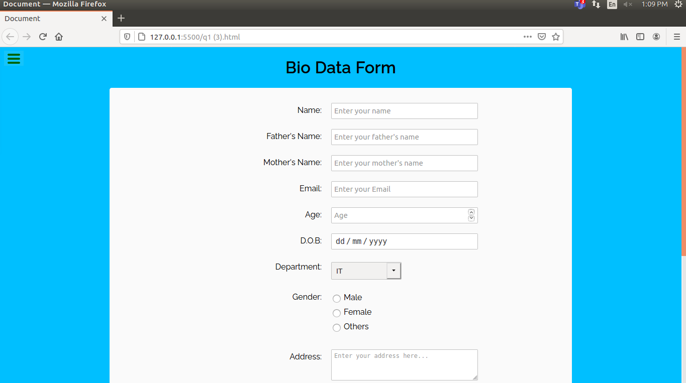
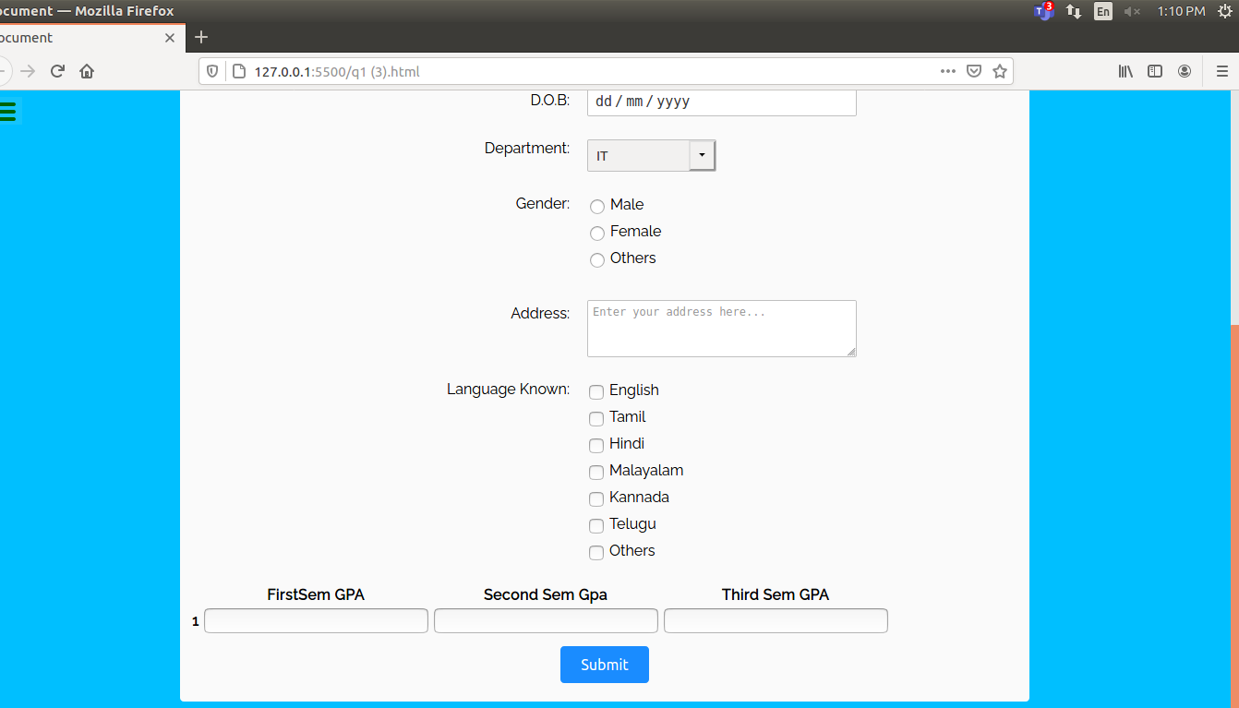

Q2

<!DOCTYPE html>
<html lang="en">
<head>
<title>Bootstrap Example</title>
<meta charset="utf-8" />
<meta content="width=device-width, initial-scale=1" name="viewport" />
<link
href="https://maxcdn.bootstrapcdn.com/bootstrap/4.4.1/css/bootstrap.min.css"
rel="stylesheet"
/>
<script src="https://ajax.googleapis.com/ajax/libs/jquery/3.4.1/jquery.min.js"></script>
<script src="https://cdnjs.cloudflare.com/ajax/libs/popper.js/1.16.0/umd/popper.min.js"></script>
<script src="https://maxcdn.bootstrapcdn.com/bootstrap/4.4.1/js/bootstrap.min.js"></script>
<script
src="https://code.jquery.com/jquery-3.5.1.slim.min.js"
integrity="sha256-4+XzXVhsDmqanXGHaHvgh1gMQKX40OUvDEBTu8JcmNs="
crossorigin="anonymous"
></script>
<script type="text/javascript">
var name = "",
email = "";

$(document).ready(function () {
$("#btnSubmit").click(function () {
name = $("#nameinput").val();
email = $("#emailinput").val();

$("#nameval").text("Name: " + name);
$("#emailval").text("Email: " + email);

$("#nameupdate").val(name);
$("#emailupdate").val(email);
});

$("#btnRead").click(() => {
$("#readname").text(name);
$("#reademail").text(email);
});

$("#btnUpdate").click(function () {
name = $("#nameupdate").val();
email = $("#emailupdate").val();

$("#nameval").text("Name: " + name);
$("#emailval").text("Email: " + email);

$("#nameupdate").val(name);
$("#emailupdate").val(email);
});

$("#btnDelete").click(() => {
name = "";
email = "";

$("#readname").text("");
$("#reademail").text("");
$("#nameinput").val("");
$("#emailinput").val("");
$("#nameupdate").val("");
$("#emailupdate").val("");
});
});
</script>
</head>
<body style="background-color: powderblue">
<div class="container">
<h3>Create</h3>
<form>
<div class="form-group">
<label for="exampleInputEmail1">Name</label>
<input
type="text"
class="form-control"
id="nameinput"
aria-describedby="emailHelp"
placeholder="Sahil Saini"
/>
</div>
<div class="form-group">
<label for="exampleInputEmail1">Email</label>
<input
type="text"
class="form-control"
id="emailinput"
aria-describedby="emailHelp"
placeholder="example@gmail.com"
/>
</div>
<input
type="button"
class="btn btn-success btnSeccion"
id="btnSubmit"
value="Create"
/>
</form>
<br />
<h6>Data:</h6>
<div class="container" id="data">
<p id="nameval">Name: No Data</p>
<p id="emailval">Email: No Data</p>
</div>
<h3>Read</h3>
<input
type="button"
class="btn btn-success btnSeccion"
id="btnRead"
value="Read Data"
/>
<br /><br />
<div class="container" id="data">
<table class="table">
<thead>
<tr>
<th scope="col">Name</th>
<th scope="col">Email</th>
</tr>
</thead>
<tbody>
<tr>
<td id="readname"></td>
<td id="reademail"></td>
</tr>
</tbody>
</table>
</div>
<h3>Update</h3>
<div class="container" id="data">
<form>
<div class="form-group">
<label for="exampleInputEmail1">Name</label>
<input
type="text"
class="form-control"
id="nameupdate"
aria-describedby="emailHelp"
placeholder=""
/>
</div>
<div class="form-group">
<label for="exampleInputEmail1">Email</label>
<input
type="text"
class="form-control"
id="emailupdate"
aria-describedby="emailHelp"
placeholder=""
/>
</div>
<input
type="button"
class="btn btn-success btnSeccion"
id="btnUpdate"
value="Update"
/>
</form>
</div>
<br />
<h3>Delete</h3>
<input
type="button"
class="btn btn-success btnSeccion"
id="btnDelete"
value="Delete Data"
/>
<br /><br />
</div>
</body>
</html>

Output:

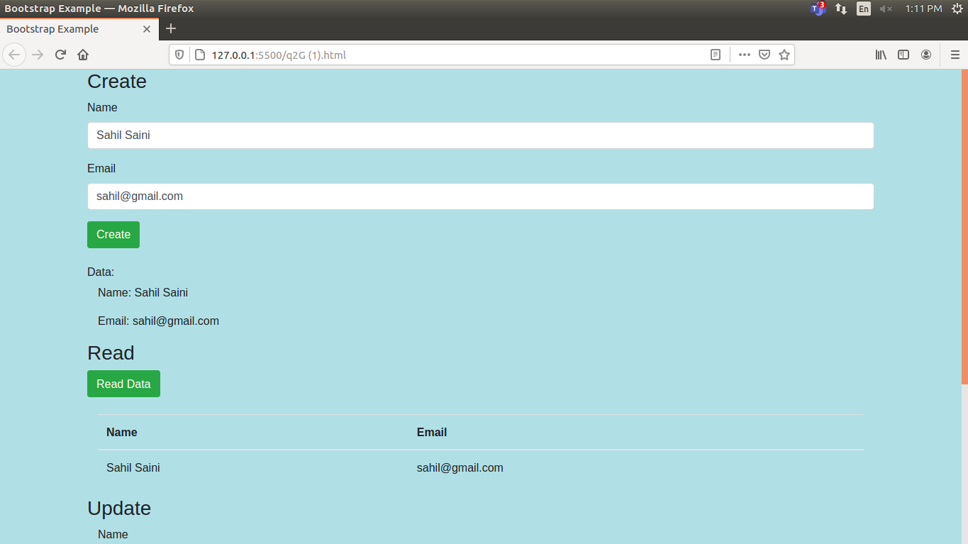
AFTER UPDATE:
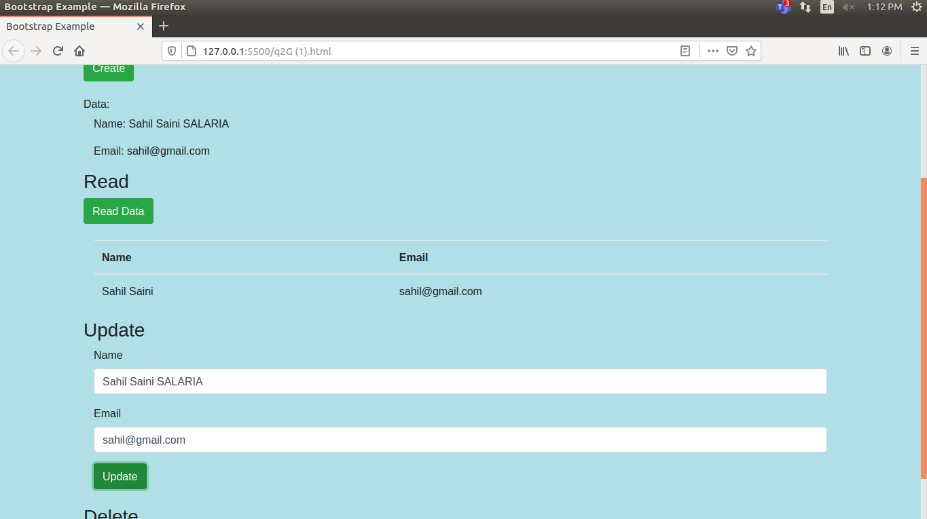
AFTER DELETE:
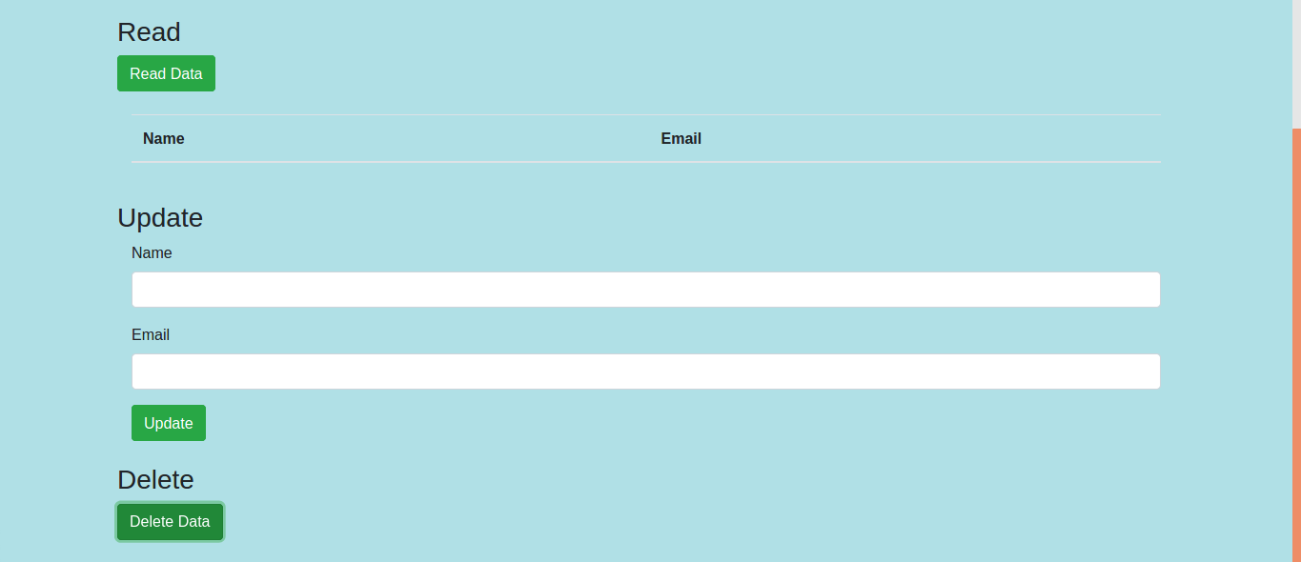

Q3

<html lang="en">
<head>
<meta charset="UTF-8" />
<meta http-equiv="X-UA-Compatible" content="IE=edge" />
<meta name="viewport" content="width=device-width, initial-scale=1.0" />

<!-- Latest compiled and minified CSS -->
<link
rel="stylesheet"
href="https://maxcdn.bootstrapcdn.com/bootstrap/3.3.7/css/bootstrap.min.css"
integrity="sha384-BVYiiSIFeK1dGmJRAkycuHAHRg32OmUcww7on3RYdg4Va+PmSTsz/K68vbdEjh4u"
crossorigin="anonymous"
/>

<title>Document</title>
</head>

<body style="background-color: #a1cae2;">
<div class="container">
<div class="row">
<div class="col-sm-6">
<p style="font-size: 130%; font-weight: bold">Login</p>
<input
type="email"
class="form-control"
placeholder="Enter email"
id="email"
style="margin-bottom: 2%; margin-top: 2%"
/>
<input
type="password"
class="form-control"
placeholder="Enter password"
id="pwd"
style="margin-bottom: 2%; margin-top: 2%"
/>
<input
class="form-check-input"
type="checkbox"
style="margin-bottom: 2%; margin-top: 2%"
/>
Remember me
</div>
<div class="col-sm-6">
<img src="login.jpeg" alt="Login" style="height: auto; width: 30%;" />
</div>
</div>

<div class="row" style="margin-top: 5%">
<div class="col-sm-4">
<form action="/action_page.php">
<div class="form-check">
<label
class="form-check-label"
for="check1"
style="margin-bottom: 2%; margin-top: 2%"
>
<input
type="checkbox"
class="form-check-input"
id="check1"
name="option1"
value="something"
checked
/>Student
</label>
</div>
<div class="form-check">
<label class="form-check-label" for="check2">
<input
type="checkbox"
class="form-check-input"
id="check2"
name="option2"
value="something"
/>Phd
</label>
</div>
<div class="form-check">
<label class="form-check-label">
<input type="checkbox" class="form-check-input" disabled />Admin
</label>
</div>
</form>
</div>
<div class="col-sm-4">
<p style="font-size: 130%; font-weight: bold">Upload ID</p>
<form action="/action_page.php">
<input type="file" id="myFile" name="filename" />
</form>
</div>
<div class="col-sm-4">
<button type="submit" class="btn btn-primary">Submit</button>
</div>
</div>
</div>
</body>
</html>

Output:

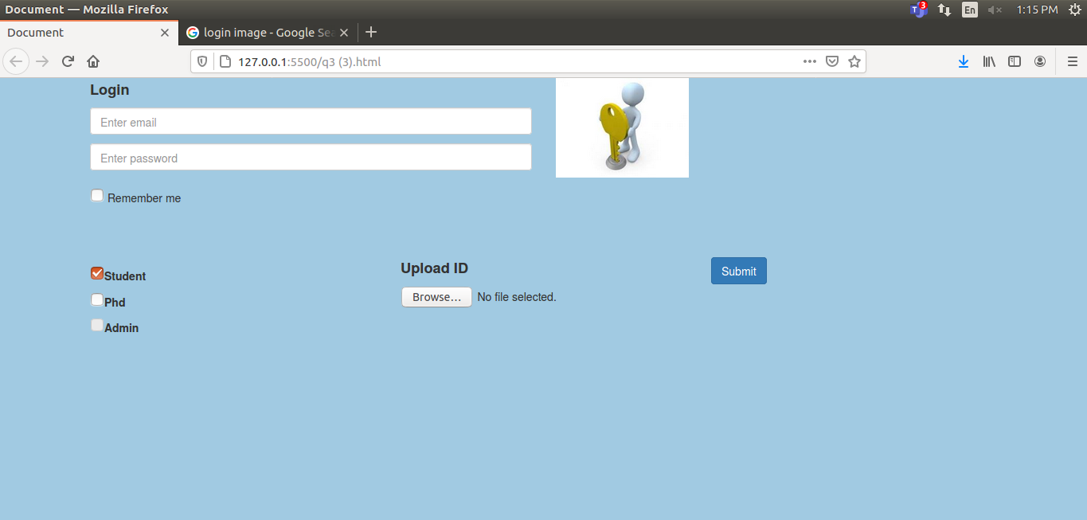

Q4

<!DOCTYPE html>
<html lang="en">
<head>
<link rel="stylesheet" href="https://stackpath.bootstrapcdn.com/bootstrap/4.1.3/css/bootstrap.min.css" integrity="sha384-MCw98/SFnGE8fJT3GXwEOngsV7Zt27NXFoaoApmYm81iuXoPkFOJwJ8ERdknLPMO" crossorigin="anonymous">
<meta charset="UTF-8">
<meta http-equiv="X-UA-Compatible" content="IE=edge">
<meta name="viewport" content="width=device-width, initial-scale=1.0">
<title>Document</title>
</head>
<body style="background-color:bisque;">

<nav class="navbar navbar-expand-sm" style="background-color: green;">

<!-- Links -->
<ul class="navbar-nav" >
<li class="nav-item">
<img src="logo.jpg" style="height: 10ch;" alt="">
</li>
<li class="nav-item">
<a class="nav-link" href="#" style="color: black; font-size: larger;"> Section A</a>
</li>
<li class="nav-item">
<a class="nav-link" href="#" style="color: black; font-size: larger;">Section B</a>
</li>
<li class="nav-item">
<a class="nav-link" href="#" style="color: black; font-size: larger;">Section C</a>
</li>
</ul>

</nav>

<div id="carouselExampleControls" class="carousel slide" data-ride="carousel">
<div class="carousel-inner">
<div class="carousel-item active">

<table class="table table-bordered table-dark">
<thead>
<tr>
<th scope="col"></th>
<th></th>
<th scope="col">8-10</th>
<th scope="col">10-12</th>
<th scope="col">12-2</th>
</tr>
</thead>
<tbody>

<tr>
<th scope="row">1</th>
<td>Monday</td>
<td>DS</td>
<td>PCAP</td>
<td>IT Lab</td>
</tr>
<tr>
<th scope="row">2</th>
<td>Tuesday</td>
<td>EEFM</td>
<td>--</td>
<td>OE-III</td>
</tr>
<tr>
<th scope="row">3</th>
<td>Wednesday</td>
<td>PCAP</td>
<td>DS Lab</td>
<td>--</td>
</tr>
<tr>
<th scope="row">3</th>
<td>Thursday</td>
<td>PE-II</td>
<td>--</td>
<td>PE-I</td>
</tr>
<tr>
<th scope="row">3</th>
<td>Friday</td>
<td>DS</td>
<td>PCAP Lab</td>
<td>EEFM</td>
</tr>
<tr>
<th scope="row">3</th>
<td>Saturday</td>
<td>--</td>
<td>PE-II</td>
<td>OE-III</td>
</tr>
</tbody>
</table>
</div>
<div class="carousel-item">

<table class="table table-bordered table-dark">
<thead>
<tr>
<th scope="col"></th>
<th></th>
<th scope="col">8-10</th>
<th scope="col">10-12</th>
<th scope="col">12-2</th>
</tr>
</thead>
<tbody>

<tr>
<th scope="row"></th>
<td>Monday</td>
<td>DS</td>
<td>PCAP</td>
<td>IT Lab</td>
</tr>
<tr>
<th scope="row">2</th>
<td>Tuesday</td>
<td>EEFM</td>
<td>--</td>
<td>OE-III</td>
</tr>
<tr>
<th scope="row">3</th>
<td>Wednesday</td>
<td>PCAP</td>
<td>DS Lab</td>
<td>--</td>
</tr>
<tr>
<th scope="row">3</th>
<td>Thursday</td>
<td>PE-II</td>
<td>--</td>
<td>PE-I</td>
</tr>
<tr>
<th scope="row">3</th>
<td>Friday</td>
<td>DS</td>
<td>PCAP Lab</td>
<td>EEFM</td>
</tr>
<tr>
<th scope="row">3</th>
<td>Saturday</td>
<td>--</td>
<td>PE-II</td>
<td>OE-III</td>
</tr>
</tbody>
</table>
</div>
<div class="carousel-item">

<table class="table table-bordered table-dark">
<thead>
<tr>
<th scope="col"></th>
<th></th>
<th scope="col">8-10</th>
<th scope="col">10-12</th>
<th scope="col">12-2</th>
</tr>
</thead>
<tbody>

<tr>
<th scope="row"></th>
<td>Monday</td>
<td>DS</td>
<td>PCAP</td>
<td>IT Lab</td>
</tr>
<tr>
<th scope="row">2</th>
<td>Tuesday</td>
<td>EEFM</td>
<td>--</td>
<td>OE-III</td>
</tr>
<tr>
<th scope="row">3</th>
<td>Wednesday</td>
<td>PCAP</td>
<td>DS Lab</td>
<td>--</td>
</tr>
<tr>
<th scope="row">3</th>
<td>Thursday</td>
<td>PE-II</td>
<td>--</td>
<td>PE-I</td>
</tr>
<tr>
<th scope="row">3</th>
<td>Friday</td>
<td>DS</td>
<td>PCAP Lab</td>
<td>EEFM</td>
</tr>
<tr>
<th scope="row">3</th>
<td>Saturday</td>
<td>--</td>
<td>--</td>
<td>--</td>
</tr>
</tbody>
</table>
</div>
</div>
<a class="carousel-control-prev" href="#carouselExampleControls" role="button" data-slide="prev">
<span class="carousel-control-prev-icon" aria-hidden="true"></span>
<span class="sr-only">Previous</span>
</a>
<a class="carousel-control-next" href="#carouselExampleControls" role="button" data-slide="next">
<span class="carousel-control-next-icon" aria-hidden="true"></span>
<span class="sr-only">Next</span>
</a>
</div>

</body>
</html>

Output:





